Joe Merrill 17FEB21
CMSC412 Homework 6

0 – Exit
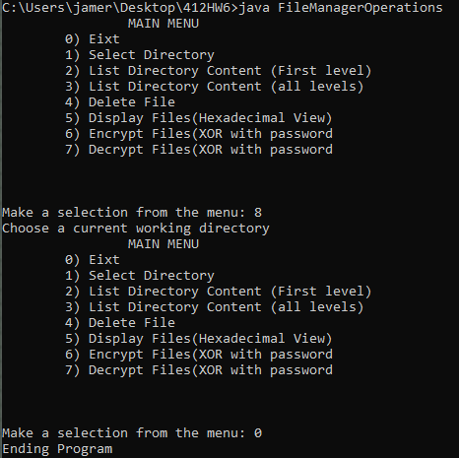
1 – Select directory
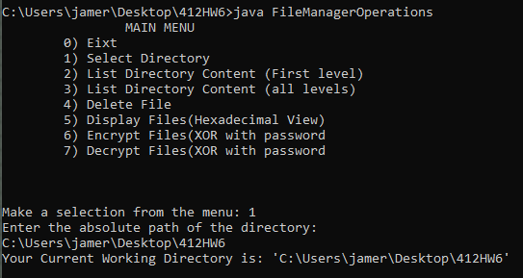
2 – List directory content (first level)
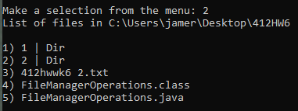

3 – List directory content (all levels)
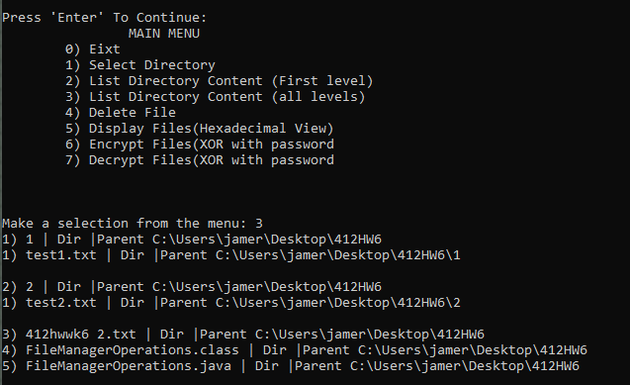
4 – Delete file
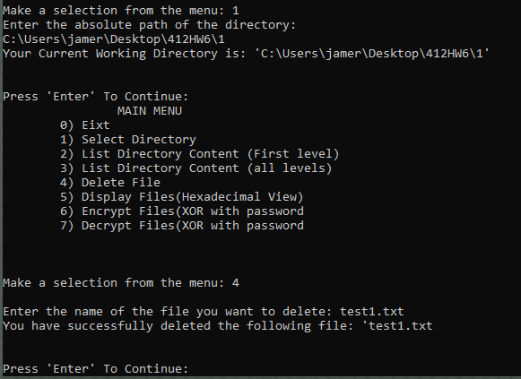
5 – Display file (hexadecimal view)
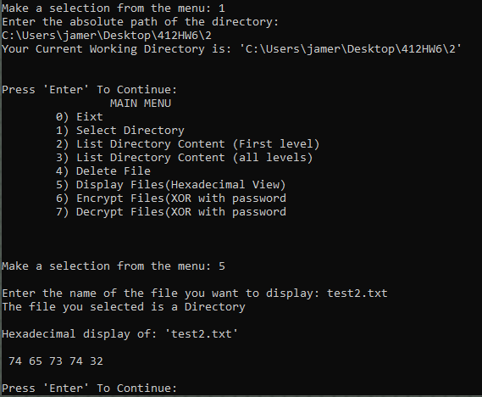

6 – Encrypt file (XOR with password)
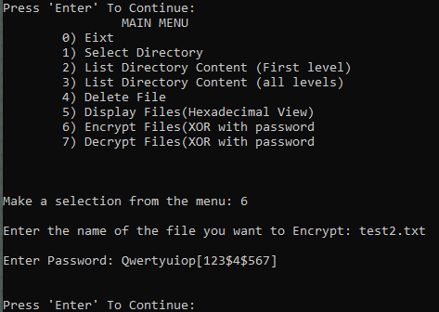
7 – Decrypt file (XOR with password)

